Unit 8 Assignment : Clustering (winequality_red.csv)

DS Chin
University of Maryland Global Campus
Data 645
Dr. Firdu Bati
May 5, 2026

Introduction

Objective
The primary objective of this project is to apply k-means clustering to perform an analysis that reveals natural groupings and hidden insights within the chemical composition of red wine. By utilizing the dataset ‘winequality_red.csv’, this study seeks to determine whether specific chemical markers - such as acidity levels, pH, and alcohol content - can effectively segment wines into distinct, identifiable clusters without the use of predefined labels.

Problem Domain
The global wine industry, valued at approximately $328.5 billion in 2026, is currently defined by a shift toward premiumization, as consumers increasingly prioritize quality over volume. While red wine remains the market leader - commanding nearly 48% of the global market share - the industry faces significant volatility from fluctuating international tariffs and evolving consumer preferences. By identifying the specific clusters of chemical attributes that define a high-quality vintage, producers can better align their outputs with the precise sensory expectations of an increasingly selective and affluent market.
Because maintaining consistency is vital for brand reputation, winemakers and distributors must manage the constant challenge of subtle chemical variations. Fluctuations in properties such as volatile acidity or sulfur dioxide levels can significantly impact a wine's final quality and market value. Applying data mining techniques to these attributes opens up the possibility for a more granular understanding of product variety; for instance, clustering can help identify outlier batches or categorize wines into segments that share similar sensory profiles. Ultimately, these insights drive more informed production and marketing strategies in a competitive global landscape.

Method Rationale
K-means clustering is the selected methodology for this analysis due to its effectiveness in identifying spatial patterns within high-dimensional datasets. As an unsupervised learning technique, k-means is uniquely suited for this problem as it does not rely on target labels (like a quality score), but instead partitions the 1,599 observations into k distinct clusters by minimizing the within-cluster sum of squares. This method is particularly relevant here because it allows for the discovery of natural segments of wine that might not be captured by traditional classification. To ensure statistical rigor and to address the black box challenge of unsupervised models, the Elbow Method will be employed to mathematically determine the optimal number of clusters.

Analysis

Data
The dataset used for this analysis is the UCI Red Wine Quality dataset, originally sourced from the UCI Machine Learning Repository. It contains 1,599 observations of red "Vinho Verde" wine samples from the north of Portugal. Each observation is characterized by 11 physicochemical variables derived from laboratory tests, along with one sensory output variable: quality (rated on a scale from 0 to 10). The following table provides a summary of the variables in the ‘winequality_red.csv’:

Feature | Scale (Min - Max) | Unit of Measurement | Description
Fixed Acidity | 4.60 – 15.90 | g/dm³ | Tartaric acid concentrations.
Volatile Acidity | 0.12 – 1.58 | g/dm³ | Acetic acid (vinegar) levels.
Citric Acid | 0.00 – 1.00 | g/dm³ | Adds freshness to the palate.
Residual Sugar | 0.90 – 15.50 | g/dm³ | Sugar remaining after fermentation.
Chlorides | 0.01 – 0.61 | g/dm³ | Amount of salt in the wine.
Free Sulfur Dioxide | 1.00 – 72.00 | mg/dm³ | Prevents oxidation (SO_2).
Total Sulfur Dioxide | 6.00 – 289.00 | mg/dm³ | Total SO_2 (free + bound).
Density | 0.99 – 1.00 | g/cm³ | Mass per unit volume.
pH | 2.74 – 4.01 | pH Scale (0-14) | Level of acidity/basicity.
Sulphates | 0.33 – 2.00 | g/dm³ | Contributes to SO_2 levels.
Alcohol | 8.40 – 14.90 | % vol | Percent content by volume.

Exploratory Data Analysis (EDA)
The EDA phase began with a rigorous assessment of data integrity using the .shape and .info() functions. This initial check confirmed a robust dataset consisting of 1,599 observations and 12 variables. The output of .info() and .isnull().sum() (Figure 1) verified that all features are stored as numerical types (float64 and int64) with zero missing values, establishing a clean foundation for distance-based modeling.
A review of the descriptive statistics, generated via the .describe() function (Figure 2), provided a baseline for the chemical makeup of the samples. Noteworthy observations include the wines exhibiting an average alcohol content of approximately 10.4% and a mean pH of 3.31. Interestingly, observing the descriptive statistics of the quality variable showed a tight concentration - confirmed later by the histograms (Figure 3) and boxplots (Figure 4) - it became evident that the majority of samples are clustered between scores of 5 and 7. This indicates that the dataset primarily represents average quality wines, with very few samples at the extreme ends of the quality spectrum.
To understand the relationships between these chemical markers, a correlation matrix was computed using the .corr() function and visualized through a heatmap (Figure 5). This analysis highlighted several significant interactions. For instance, fixed acidity showed a strong positive correlation with density, as higher concentrations of organic acids physically increase the liquid's mass. More importantly for the project's objectives, alcohol demonstrated a notable positive correlation with quality, while volatile_acidity showed a distinct negative correlation, confirming that higher vinegar-like notes generally detract from sensory ratings.
Visual inspection was further conducted through boxplots and histograms to assess the readiness of the data for k-means. Boxplots revealed the presence of significant outliers in variables such as residual_sugar and chlorides (Figure 6). Because k-means is highly sensitive to outliers - which can skew the calculation of cluster centroids - these were flagged for careful monitoring. Additionally, histograms showed that most features, particularly sulphates and alcohol (Figure 7), exhibit a right-skewed distribution. Given these variations in scale and distribution, the EDA concluded that standardization (Z-score scaling) is a mandatory step to ensure that variables with larger numerical ranges do not disproportionately influence the clustering results.

Preprocessing
To ensure the k-means algorithm identifies patterns based on chemical significance rather than arbitrary numerical scales, a rigorous preprocessing pipeline was established. The most critical step in this phase is feature standardization. In the winequality_red.csv dataset, chemical properties are measured in vastly different units; for example, totalsulfur_dioxide values often reach triple digits, while pH levels vary only by small fractions. Without standardization, the algorithm would be disproportionately driven by high-variance features, effectively treating a minor shift in sulfur levels as more significant than a major shift in acidity. To prevent this, all variables were centered to a mean of zero and scaled to a standard deviation of one, ensuring each chemical marker contributed equally to the distance calculations.

In addition to scaling, the preprocessing phase addressed the challenge of handling outliers. The exploratory analysis highlighted extreme values in features such as residual_sugar and chlorides. Because k-means relies on Euclidean distance to assign observations to groups, these outliers act as magnets that can significantly pull cluster centroids away from the primary data mass. By identifying and managing these anomalies, the resulting clusters more accurately reflect the natural groupings of the broader dataset rather than being skewed by a few non-representative samples.

Finally, while advanced techniques like Principal Component Analysis (PCA) were considered for noise reduction and high-dimensional visualization, this analysis primarily focuses on the standardized raw features. This dimensionality consideration was made to preserve the direct interpretability of the results. By clustering on the original chemical markers, the findings remain grounded in specific, actionable wine properties - such as alcohol content and volatile acidity - making the final segments more useful for winemakers and distributors who need to understand the exact chemical profile of each identified group.

Algorithm Intuition
K-means clustering represents a simple yet elegant approach to unsupervised learning, designed to partition a dataset into K distinct, non-overlapping groups. The fundamental logic governing this algorithm is the principle of similarity: a "good" clustering is defined as one where the within-cluster variation is kept as small as possible. In the context of this study, this means the algorithm strives to ensure that the chemical profiles of wines within a single cluster are as similar to one another as they can be.
To achieve this, the algorithm treats the clustering task as a mathematical optimization problem. It seeks to minimize the sum of the squared Euclidean distances between each wine observation and its assigned cluster centroid. This objective is expressed through the following equation:
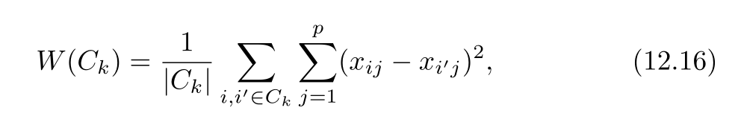
The implementation of this logic relies on two key input parameters that significantly influence the model's output. The first is K (the number of clusters), which is the primary input required from the user. Because k-means cannot automatically determine the optimal number of groups, we must pre-specify how many segments to search for within the wine data.
The second critical parameter is n_init (random initializations). Because the algorithm is an iterative process that can get stuck in a local optimum - essentially a good solution that isn't necessarily the best overall - it must be executed multiple times from different random starting positions. By increasing the number of initializations, we ensure a more robust analysis that converges on the most mathematically sound partition of the red wine dataset.

Cluster Development and Anomaly Detection
The development of the cluster model for the red wine dataset involved a process of iterative experimentation designed to refine the separation of samples into meaningful groups. Following the framework from the ISLP text, the analysis began by assigning each wine sample to a random cluster. The algorithm then entered a cycle of refinement, continuously recomputing the centroids - the mathematical center of each group - and reassigning samples to the nearest centroid until the groupings stabilized and no further movement occurred.

A critical component of this development phase was parameter tuning, specifically regarding the selection of K. To distinguish a high-performing model from a less accurate one, the Elbow Method was utilized. By plotting the total within-cluster sum of squares, also known as inertia, against a range of possible K values, the analysis sought an elbow or a point of diminishing returns (Figure 8). This drop-off point indicates the optimal number of clusters where the data's variation is sufficiently explained without overcomplicating the model.

Throughout this process, the model also served as a tool for anomaly detection. Observations that consistently remained at a high Euclidean distance from any cluster centroid were flagged as anomalies. In the context of the wine industry, these outliers represent batches with unusual chemical fingerprints. Such deviations could indicate significant production errors, such as bacterial spoilage, or conversely, identify rare, high-value vintages that possess chemical profiles distinct from standard market offerings.

Finally, because unsupervised learning lacks true labels to measure traditional accuracy, the model underwent a validation phase to ensure reliability. The stability of the clusters was verified by comparing results across multiple random initializations. This step confirmed that the identified wine segments were robust and reproducible, rather than mere artifacts of a specific random start, providing confidence in the practical application of the findings for production and marketing strategies.

Result

Output
The application of the k-means algorithm successfully partitioned the 1,599 observations into three distinct clusters, meeting the primary objective of revealing natural groupings within the chemical composition of red wine. By interpreting the output (Figure 9) in relation to the wine industry domain, we can see that these clusters represent specific product segments. For example, the model identified a "High Quality/High Alcohol" segment and a "High Volatility" segment, allowing for an automated categorization of wines based on their chemical fingerprints. The objective of segmenting wines without the use of predefined labels was fully realized, as the algorithm effectively separated the samples into groups that align with known sensory expectations - such as the negative relationship between volatile acidity and perceived quality - purely through the analysis of physicochemical markers.

Model Properties
The three identified clusters exhibit clear chemical differences and internal similarities, as visualized in the PCA-based cluster plot (Figure 10).
- Cluster 0 (purple) represents a balanced, average category, containing the largest number of samples.
- Cluster 1 (green) emerges as the premium segment, characterized by significantly higher alcohol content and lower volatile acidity. These samples consistently align with higher quality ratings (scores of 7 and 8), suggesting a group of robust, well-fermented wines.
- Cluster 2 (teal) displays higher levels of volatile acidity and lower alcohol, representing a utility or lower-tier segment.
While the clusters are non-overlapping in high-dimensional space, the cluster plots reveal that they are most distinct along the axes of alcohol and acidity. The similarity within each cluster indicates that winemakers can expect consistent sensory profiles from batches grouped together, while the differences between clusters provide a roadmap for inventory tiering and targeted marketing.

Evaluation
To quantitatively evaluate the performance of the k-means model, distance-based metrics and variance analysis were employed. The Total Within-Cluster Sum of Squares (Inertia) was measured at 12,629.97, representing the total squared Euclidean distance between each observation and its assigned centroid. A lower inertia signifies tighter, more cohesive clusters.

Furthermore, the model’s performance was evaluated using the Proportion of Variance Explained (PVE). The three-cluster solution achieved a PVE of 28.19%. In the context of unsupervised learning on complex, noisy biological data like wine chemistry, a PVE near 30% indicates that the clusters capture a substantial portion of the dataset's underlying structure. Finally, a cross-tabulation of the clusters against the sensory quality ratings (Figure 11) served as an external validation; the clear concentration of high-quality wines in Cluster 1 and average-quality wines in Cluster 0 confirms that the mathematically derived groups have significant real-world accuracy and practical utility.

Conclusion

Summary
The application of k-means clustering to the red wine dataset successfully met the objective of identifying natural groupings based on chemical composition. The analysis revealed three distinct market segments that exist independently of subjective quality ratings. The most significant finding was the identification of a premium cluster characterized by a specific chemical profile of high alcohol content and low volatile acidity, which strongly correlates with superior sensory scores.

Conversely, the model identified a utility segment where higher levels of acetic acid were the primary distinguishing factor. These findings demonstrate that unsupervised machine learning can effectively categorize wine inventory and predict market tiering using only objective laboratory measurements. For the wine industry, this provides a data-driven framework for maintaining brand consistency and optimizing production strategies to meet the precise sensory expectations of different consumer segments.

Limitations
While the k-means clustering algorithm successfully identified distinct chemical groupings, the analysis is subject to several limitations inherent in both the data and the methodology. A primary constraint is the algorithm’s reliance on Euclidean distance, which assumes that all features are equally important once standardized. However, in wine chemistry, certain trace compounds may have a disproportionate impact on flavor that mathematical scaling cannot fully capture. Additionally, the k-means algorithm is sensitive to the initial placement of centroids; despite using multiple random initializations (n_init), the model may still converge on a local optimum rather than a global one.
Furthermore, a significant limitation lies in the interpretative depth of the results. While the model provides a rigorous mathematical partition of the data, the lack of deep domain expertise in oenology (the study of wine) and food chemistry limits the analysis to a relatively broad and technical scope. For instance, the differences in the quality ratings between the identified clusters, while present, were not always drastically significant. This suggests that chemical markers alone do not tell the full story of wine excellence. The quality variable in this dataset is a subjective sensory rating, and k-means - as an objective, unsupervised tool - struggles to capture the artistic nuance and human taste that professional sommeliers provide. For example, two wines might share nearly identical pH and alcohol levels but differ immensely in "mouthfeel" or "bouquet" due to subtle differences in grape tannins or aging processes that are not represented in the CSV file.

Improvement Areas
Future iterations of this research could significantly enhance the model's accuracy and practical value by addressing the following areas:
- Domain-Specific Feature Engineering: Collaborating with food chemists to create interaction features - such as the ratio of acidity to residual sugar - could provide the algorithm with more nuanced inputs that better reflect how humans perceive flavor balance.
- Alternative Clustering Algorithms: Exploring density-based clustering (like DBSCAN) or hierarchical clustering could help identify more complex, non-spherical wine segments that k-means might overlook.
- Integration of Qualitative Data: Incorporating descriptive sensory data (e.g., tasting notes like "oak," "berry," or "earthy") via Natural Language Processing alongside the physicochemical data would bridge the gap between hard chemistry and the artistic nuance of wine tasting.
- Advanced Parameter Tuning: Future studies could employ more granular validation techniques, such as the Silhouette Coefficient or Gap Statistic, to further verify the optimal number of clusters and ensure the segments are as cohesive as possible before being used for commercial production strategies.

References:

Brunning, A. (2014, May 28). The key chemicals in red wine – colour, flavour, and potential health benefits. Compound Interest. https://www.compoundchem.com/2014/05/28/redwinechemicals/

Penn State Extension. (2026, March 30). Alcoholic beverage trends 2026. https://extension.psu.edu/alcoholic-beverage-trends-2026

Cortez, P., Cerdeira, A., Almeida, F., Matos, T., & Reis, J. (2009). Modeling wine preferences by physicochemical properties from physicochemical tests. Decision Support Systems, 47(4), 541-548. https://archive.ics.uci.edu/ml/datasets/wine+quality

James, G., Witten, D., Hastie, T., Tibshirani, R., & Taylor, J. (2023). An Introduction to Statistical Learning with Applications in Python (ISLP)
Google. (2024). Gemini (March 2024 version) [Large language model]. https://gemini.google.com/ (for assistance with coding help and writing this report)

Figure 1
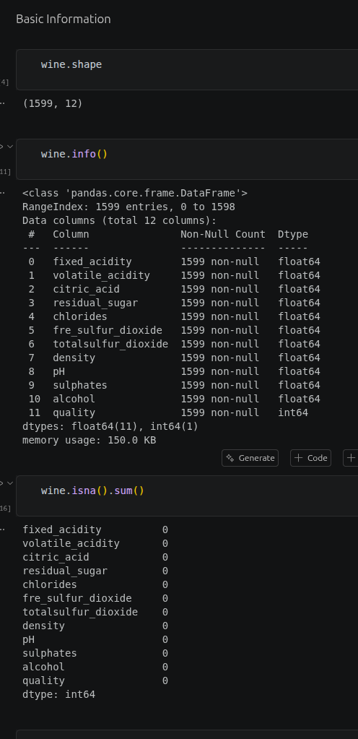

Figure 2

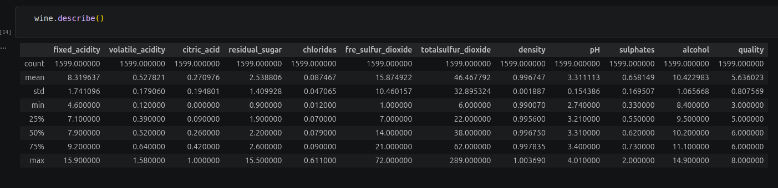

Figure 3
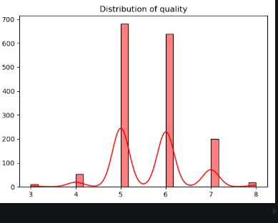

Figure 4
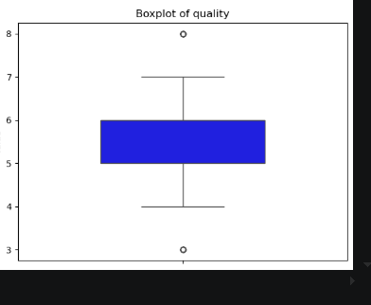

Figure 5

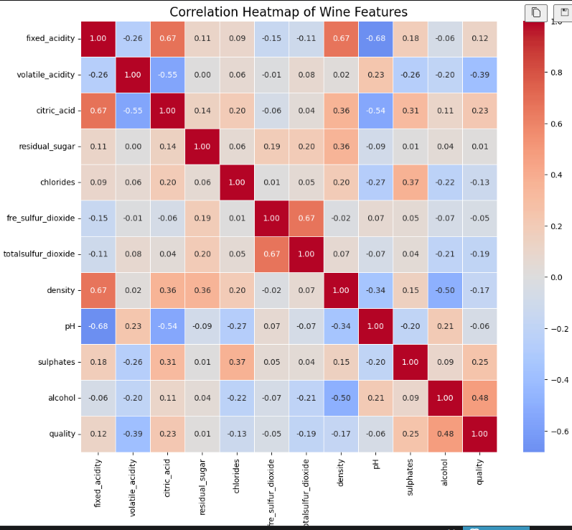

Figure 6
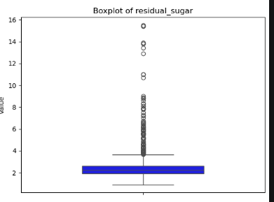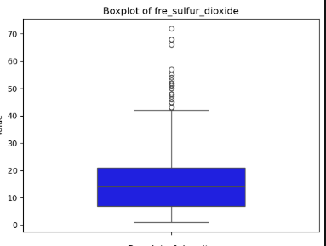
Figure 7

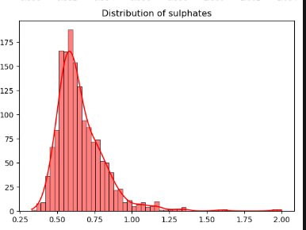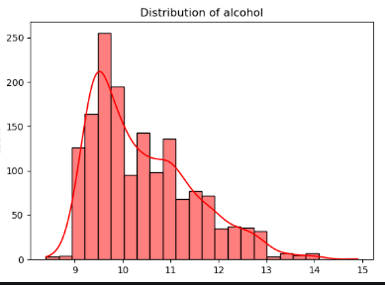

Figure 8

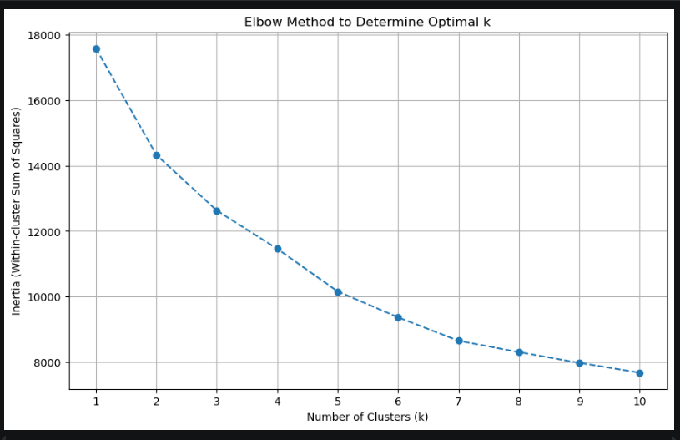

Figure 9

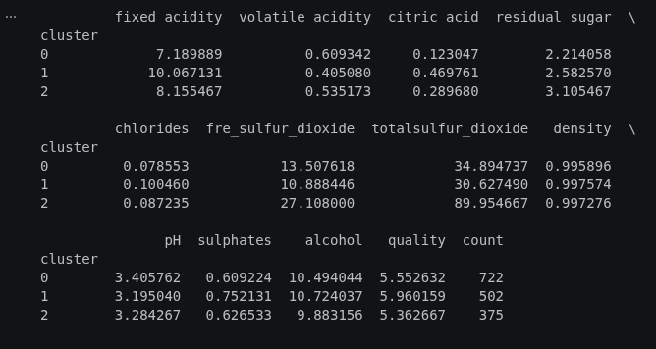

Figure 10

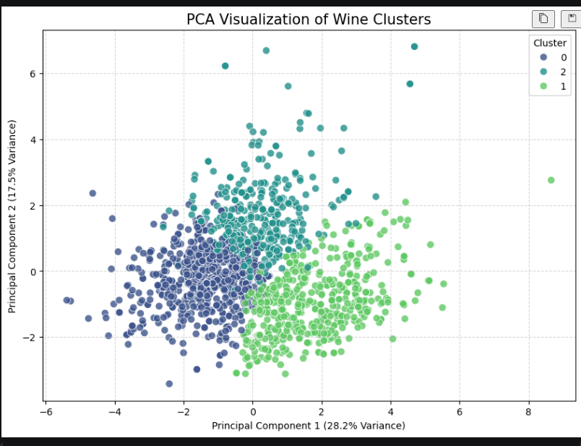

Figure 11

